**CHAPTER 1**

**ABSTRACT**

This project explores the integration of hardware components, such as ultrasonic sensors, stepper motors, and 7-segment displays, with web-based interfaces developed using the Flask framework. The goal is to demonstrate real-time interaction between sensors, actuators, and software for practical IoT applications.

The first system simulates a dynamic traffic light controller using a Raspberry Pi and a 7-segment display to visualize real-time countdowns for four traffic signals. Signal durations are randomized, and transitions between green, yellow, and red states mimic real-world traffic operations. A web interface provides remote monitoring of the signal status, illustrating the application of embedded systems in traffic management.

The second system implements distance-based automation using an ultrasonic sensor and a stepper motor. It measures object distances and adjusts motor operation accordingly. A web application displays real-time distance readings and motor status while incorporating safety mechanisms, such as timeout handling and thread-safe motor control, to ensure robust performance.

## Chapter 2

## INTRODUCTION

The integration of hardware components with web-based software interfaces has become a cornerstone of modern IoT applications, enabling seamless real-time interaction and control. This project explores the practical implementation of such systems using ultrasonic sensors, stepper motors, and 7-segment displays, combined with the Flask web framework. The primary objective is to demonstrate how embedded systems can interact with web technologies to create efficient, interactive, and automated solutions.

The project comprises two distinct systems. The first system simulates a traffic light controller using a Raspberry Pi and a 7-segment display to manage and display real-time countdowns for four traffic signals. It incorporates randomized signal durations and realistic state transitions between green, yellow, and red lights, closely replicating real-world traffic operations. Additionally, a web-based interface allows users to remotely monitor the signal statuses, offering a comprehensive example of real-time data visualization and dual-mode interaction.

The second system focuses on distance-based automation, employing an ultrasonic sensor to measure object distances and a stepper motor to perform actions based on predefined thresholds. A Flask web application provides real-time updates on distance measurements and motor status, while built-in safety mechanisms ensure robust and reliable operation. This system highlights the seamless integration of sensors and actuators with web technologies for automated and remote control.

## 2.1 Objective

The objective of this project is to integrate hardware components such as ultrasonic sensors, stepper motors, and 7-segment displays with web-based interfaces using the Flask framework to demonstrate real-time interaction and control. The project aims to showcase the practical applications of embedded systems programming in IoT, focusing on automation and remote monitoring.

The first system simulates a dynamic traffic light controller, featuring real-time countdowns and remote monitoring of traffic signals. The second system implements distance-based automation, using an ultrasonic sensor to measure proximity and control a stepper motor accordingly. Both systems highlight real-time data processing and visualization, serving as foundational examples of how embedded hardware and web technologies can be combined to address challenges in traffic management and industrial automation.

## 2.2 Problem Statement

## As technology continues to evolve, there is an increasing need for real-time, automated systems that can efficiently monitor and control physical environments. In particular, the integration of sensors, actuators, and web-based interfaces presents a challenge in ensuring smooth communication and reliable performance. Traditional traffic management systems can be inefficient and lack adaptability, while industrial automation often requires precise control based on real-time data.

## This project addresses the need for dynamic and interactive systems that combine embedded hardware with web technologies. It aims to develop a traffic light control system that can simulate real-world traffic scenarios with real-time countdowns and remote monitoring. Additionally, it aims to create a distance-based automation system using ultrasonic sensors and stepper motors to perform actions based on object proximity. Both systems seek to provide practical solutions to improve efficiency, safety, and flexibility in real-time traffic control and automation systems

## Chapter 3

## APPLICATIONS

* **Smart Traffic Management**: The traffic light control system can be used to optimize traffic flow in urban areas, adjusting signal durations based on real-time traffic conditions and minimizing congestion.
* **Industrial Automation**: The distance-based automation system can control machinery, such as robotic arms or conveyors, by adjusting operations based on proximity sensors, improving efficiency in factories.
* **Smart Homes**: Ultrasonic sensors and stepper motors can be used to automate doors or windows, adjusting their positions based on object detection or user preferences.
* **Automated Warehouses**: The integration of sensors and stepper motors can help automate material handling and storage systems by guiding robots or conveyors based on distance measurements.
* **Robotic Navigation**: The ultrasonic sensor can assist in navigation for autonomous robots, providing real-time distance measurements to avoid obstacles and enhance navigation accuracy.
* **Smart Irrigation**: Optimizes water use by monitoring soil moisture and weather conditions.
* **Leak Detection**: Uses sensors to identify and fix leaks in water pipelines.
* **Water Quality Monitoring**: Continuously checks water parameters to ensure safety and cleanliness.
* **Smart Water Meters**: Tracks real-time water usage, improving billing and conservation efforts.
* **Smart Water Meters**: Tracks real-time water usage, improving billing and conservation efforts.

## Chapter 4

## Components

## 4.1 Raspberry pi 4 Model B

## 

**Figure 4.1: Raspberry pi 4 Model B.**

The Raspberry Pi 4 Model B is a powerful single-board computer designed for a variety of applications, from education to industrial automation. It features a quad-core ARM Cortex-A72 processor, up to 8GB of RAM, dual micro-HDMI ports supporting 4K output, and USB 3.0 connectivity. Its GPIO pins enable easy interfacing with sensors, motors, and other peripherals, making it ideal for hardware projects. Built-in Wi-Fi, Bluetooth, and Ethernet provide versatile networking options. The Pi 4 is a versatile platform for learning, prototyping, and deploying IoT and embedded systems solutions.

## 4.2 Ultrasonic Sensor

## 

**Figure 4.2: Ultrasonic Sensor.**

An ultrasonic sensor is a device that measures distance by emitting ultrasonic sound waves and detecting their reflection from objects. It calculates the distance based on the time taken for the sound waves to travel to the object and back. These sensors are widely used in applications like obstacle detection, level measurement, and robotics. They are reliable, non-contact devices that work well in various environments. Ultrasonic sensors are ideal for measuring distances in the range of a few centimeters to several meters.

## 4.3 Stepper Motor

## 

**Figure 4.3: Stepper Motor.**

A **stepper motor** is a type of motor that moves in precise, fixed increments, allowing for accurate control of position. It operates by receiving electrical pulses, which move the motor in small steps. Stepper motors are widely used in applications requiring precise rotation, such as robotics and automation. They can rotate in both directions and are known for their ability to maintain position without needing continuous power. These motors are reliable, easy to control, and ideal for tasks that require consistent and controlled movement.

## 4.4 Seven Segment LCD Display

## 

**Figure 4.4: Seven Segment LCD Display.**

A **7-segment LCD display** is an electronic display used to show numerical digits and some characters. It consists of seven segments that can be turned on or off to form numbers from 0 to 9. These displays are commonly used in devices like digital clocks, calculators, and meters. They are simple to interface with microcontrollers and offer clear visibility. Each segment is controlled individually, providing an energy-efficient way to display information.

**Chapter 5**

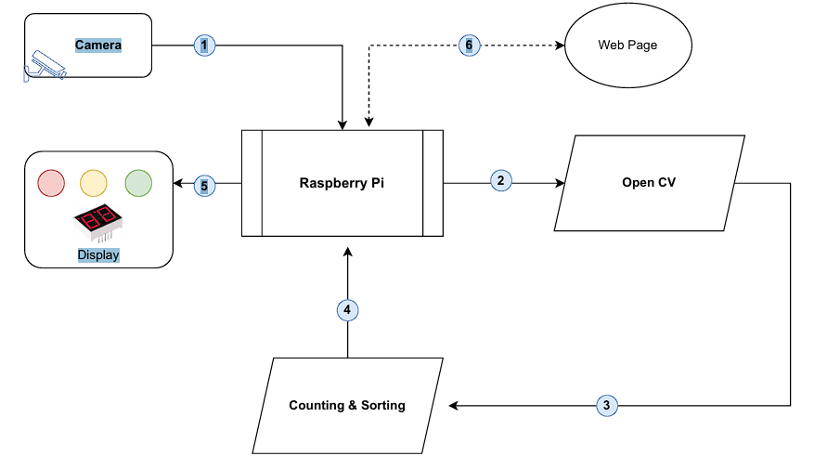**Flow Chart**

**Figure 5.1: Traffic Management.**

The Description Of The Traffic Management System,as per the flowchart:

Step 1: Traffic Monitoring:

A camera is used to capture real-time footage of the traffic.

Step 2: Image Processing:

The captured data is sent to the Raspberry Pi, which utilizes OpenCV for processing.

The system performs counting and sorting of vehicles based on the traffic density.

Step 3: Counting and Sorting Vehicles:

The processed information determines traffic control actions, such as the timing of

signals or priority of lanes.

The system counts the number of vehicles and sorts them based on traffic density or

predefined categories.

Ste 4: After Counting and Sorting data is sent to Raspberry Pi.

Step 5: Status Display:

The traffic information, including vehicle counts and control decisions, is sent to a

display for local visibility.

Step 6: Web-Based Monitoring:

The processed traffic data is uploaded to a web page, enabling remote monitoring and

management of traffic flow.

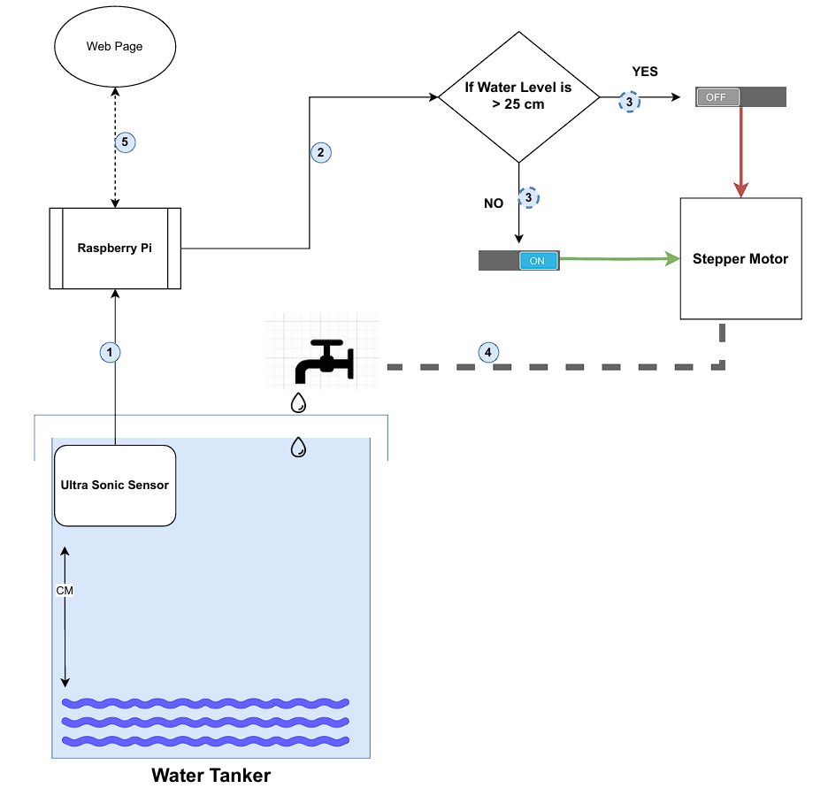

**Figure 5.2: Water Management.**

The Description of The Water Management System, as per the flowchart:

Step 1: Water Level Measurement:

The ultrasonic sensor measures the water level in the tank and sends the data to the

Raspberry Pi.

step 2: Decision Check:

The system checks if the water level is greater than 25 cm.

Step 3: Condition Handling:

YES (Water Level > 25 cm):

The stepper motor is turned OFF to stop water inflow.

NO (Water Level ≤ 25 cm):

The stepper motor is turned ON to allow water inflow.

Step 4: Water Will flow in to the tank when the motor is on , if the water level is less than

25cm.

Step 5: Status Update:

The current water level and the motor state (ON/OFF) are displayed on a web page

for real-time monitoring.

System Loop:

The process continuously loops to ensure consistent water level management.

**Chapter 6**

**CONCLUSION**

In conclusion, this project demonstrates the effective integration of embedded hardware components such as ultrasonic sensors, stepper motors, and 7-segment displays with web-based interfaces, showcasing the potential of IoT applications. The systems developed, including the dynamic traffic light controller and the distance-based automation system, highlight the importance of real-time data processing and automation in modern technology. By combining sensors, actuators, and web technologies, the project provides practical solutions for traffic management, industrial automation, and other real-world applications. This integration of embedded systems with web interfaces offers significant potential for enhancing efficiency, safety, and remote monitoring in various domains.

**Chapter 7**

**FUTURE WORK**

* **Traffic Light System:** Implement real-time traffic data and machine learning to optimize signal timings.
* **Distance Automation:** Use multiple sensors and cloud integration for better data management and control.
* **Actuator Expansion:** Add more actuators for broader applications in robotics and automation.
* **User Interface:** Improve the interface with mobile support for easier remote control.

**Chapter 8**

**APPENDIX**

**8.1 Pseudocode**